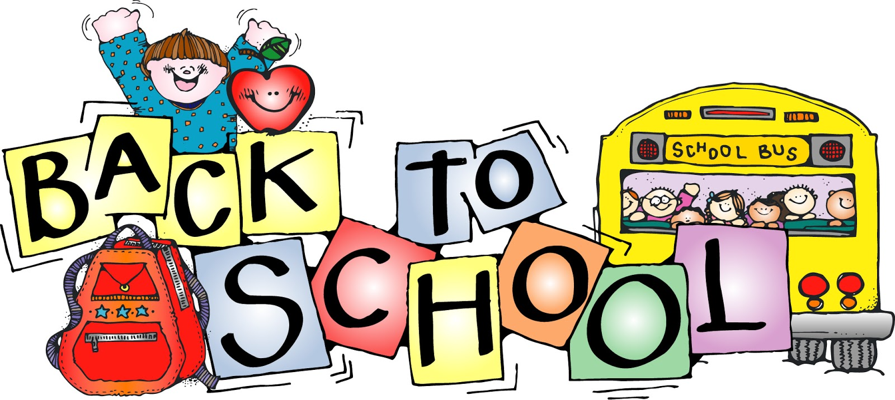
Dear parents, Fri Sept. 1st, 2017

Welcome to a new school year! I am very happy to be teaching your child in grade one this year.

I’m sending this letter home to you in your child’s B.E.E. Binder. The B.E.E. Binder is a very important communication tool, that needs to go back and forth everyday. Please remember to check it daily. Very soon I’ll be sending you an explanation as to how we will be using it this year. We are waiting for some of the things that belong inside the B.E.E. Binder to arrive. The agenda, that has already arrived, is one of the ways that you can communicate with me this year. Please also feel free to email me at areynoldshamelin@swlauriersb.qc.ca.

In the weeks to come I’ll be sending home a schedule in the B.E.E. Binder. This year Phys. Ed. will be on Tuesdays and Thursdays. Please dress your child for Phys. Ed. (jogging pants or shorts, t-shirts, socks, etc.) on those mornings, starting Tues. Sept. 5th.

I am looking forward to meeting everyone at our Curriculum Night, Thursday September 14th. I send home a weekly information sheet via email. I’ll start sending it next week. If your email address is different from the one you gave Ms. Kowch or you have not yet given an email address to the school please either email me or write your address in your child’s agenda so that I am able to send you my weekly information and reminders of important events. Thank you.

Enjoy the long weekend,

Ms. Reynolds

